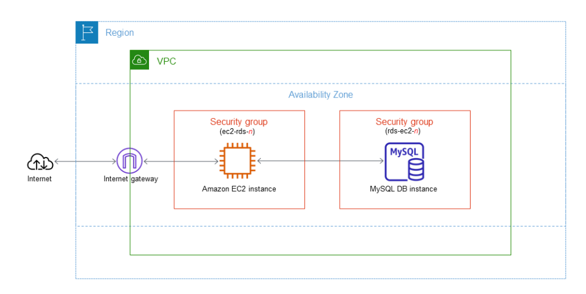

* [**Step 1: Create a MySQL DB instance**](https://docs.aws.amazon.com/AmazonRDS/latest/UserGuide/CHAP_GettingStarted.CreatingConnecting.MySQL.html#CHAP_GettingStarted.Creating.MySQL)**:**

*Go to RDS service and create a database.

*Choose easy create as database creation method

*Choose MySQL as configuration

*Select DB instance size and identifier (name for the database)

*Create a master username. After that you can either autogenerate a master password or you can do it manually.

*Create a database.

*You can view the credential details of the master.

*Wait until the database status become available.

* [**Step 2: Create an EC2 instance**](https://docs.aws.amazon.com/AmazonRDS/latest/UserGuide/CHAP_GettingStarted.CreatingConnecting.MySQL.html#CHAP_GettingStarted.Creating.MySQL.EC2)**:**

*Go to EC2 service and click on launch instance.

*Give a name for the instance.

*Choose an AMI image if you are choosing Amazon linux make sure that the image is previous version of 2023 as it doesnot support MySQL.

*Choose instance type and create a keypair.

*In the network settings make sure that the instance is created in the same VPC and subnet as of the previously created RDS database.

*Auto assign the public IP. And create a security group with inbound rules of type SSH and source type My IP.

*Launch the instance.

* [**Step 3: Connect your EC2 instance and MySQL DB instance automatically**](https://docs.aws.amazon.com/AmazonRDS/latest/UserGuide/CHAP_GettingStarted.CreatingConnecting.MySQL.html#CHAP_GettingStarted.Connecting.EC2.MySQL)**:**

*Now go to RDS to connect the database to the EC2 that was created.

*Go to database in the actions click on set up EC2 connection.

*Select the EC2 instance and continue.

*Review the connection summary and confirm and setup.

* [**Step 4: Connect to a MySQL DB instance**](https://docs.aws.amazon.com/AmazonRDS/latest/UserGuide/CHAP_GettingStarted.CreatingConnecting.MySQL.html#CHAP_GettingStarted.Connecting.MySQL)**:**

*Connect the Ec2 instance using the SSH client

*Check whether the instance is updated or not using the following command:

sudo yum update -y

*Give the command sudo yum install mariadb

*Connect the MySQL database using the command:

mysql -h endpoint -P 3306 -u admin -p

🡪You can get the end point in the connectivity & security of the database created.

*Run SQL commands for example,

SELECT CURRENT_TIMESTAMP;

*Create a sample table.

🡪CREATE DATABASE sampledb;

🡪USE sampledb;

CREATE TABLE sampletable (

id INT NOT NULL AUTO_INCREMENT,

name VARCHAR(50) NOT NULL,

PRIMARY KEY (id)

);

🡪SHOW TABLES;

🡪INSERT INTO sampletable (name) VALUES ('John');

INSERT INTO sampletable (name) VALUES ('Jane');

🡪SELECT * FROM sampletable;

* [**Step 5: Delete the EC2 instance and DB instance**](https://docs.aws.amazon.com/AmazonRDS/latest/UserGuide/CHAP_GettingStarted.CreatingConnecting.MySQL.html#CHAP_GettingStarted.Deleting.MySQL)**:**

*Delete the created EC2 instances and Database.